# Dexavier Williams

Ultimate Switch Generator

This project was done around January 2019 for my Physical Computing class.

Story

My project is a mock-up power generator based on the Ironman series. I have placed it in the middle of this stuffed animal to simulate a device that Tony Stark would develop. The design is incredibly straightforward, every time you flick the switch it simulates the act of acquiring more power. For this project, I used a part of a MakeCode tutorial based around toggle switches. This time, however, it was expanded upon rather than just turning something on and off.

As soon as you put the code into the device, the green immediately switches to either blue with the regular brightness or blue and red with flickering brightened lights. For this project to work, it would be preferred that the express starts out on blue. For it to start out on blue the knob must be turned towards 6A. When you turn the switch in the opposite direction the red and blue lights flicker and do that until you turn it back towards 6A. When it is back at blue the lights are brighter and simulating a powered-up generator.

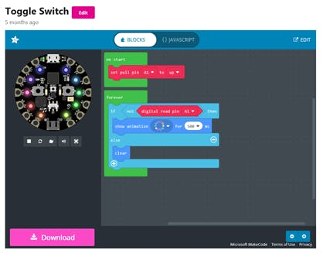

This is the code I borrowed from.

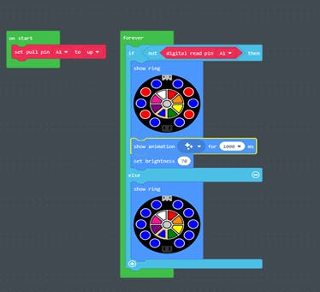

This is the final code I used.

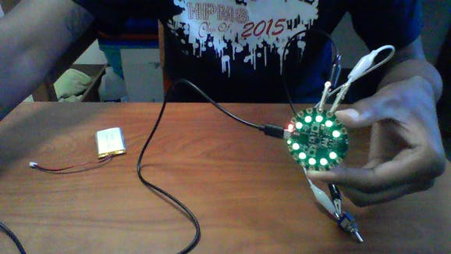

First Stage of the project. The white wire is connected to A1, while the black one is connected to GND.

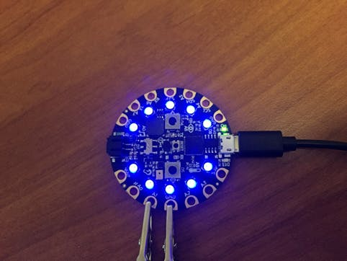

Once I put my code onto the device, it pulsates blue lights. The knob is pointed in the 6A direction.

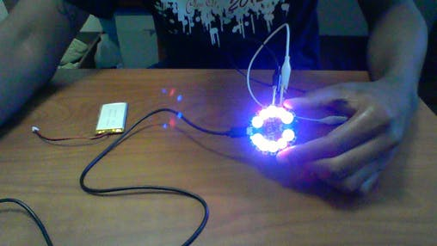

Once I flip the switch in the opposite direction, the lights become red and blue and are in a flickering state.

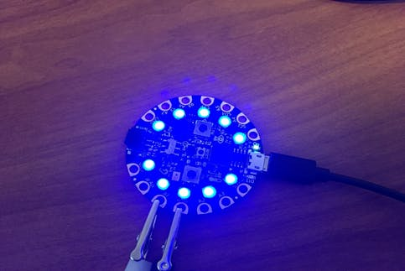

Once I turn it back, the blue lights are now glowing brighter than before.